Session 8:
- CREATE PROCEDURE show_user() BEGIN DECLARE v_name VARCHAR(50) DEFAULT 'Dipesh'; DECLARE v_age INT DEFAULT 21; SELECT v_name AS name, v_age AS age; END;

- CREATE PROCEDURE q2() BEGIN DECLARE v_order_amount INT DEFAULT 750; -- change this to test IF v_order_amount > 500 THEN SELECT 'Eligible for free delivery' AS 'Message'; ELSE SELECT 'Delivery charges apply' AS 'Message'; END IF; END;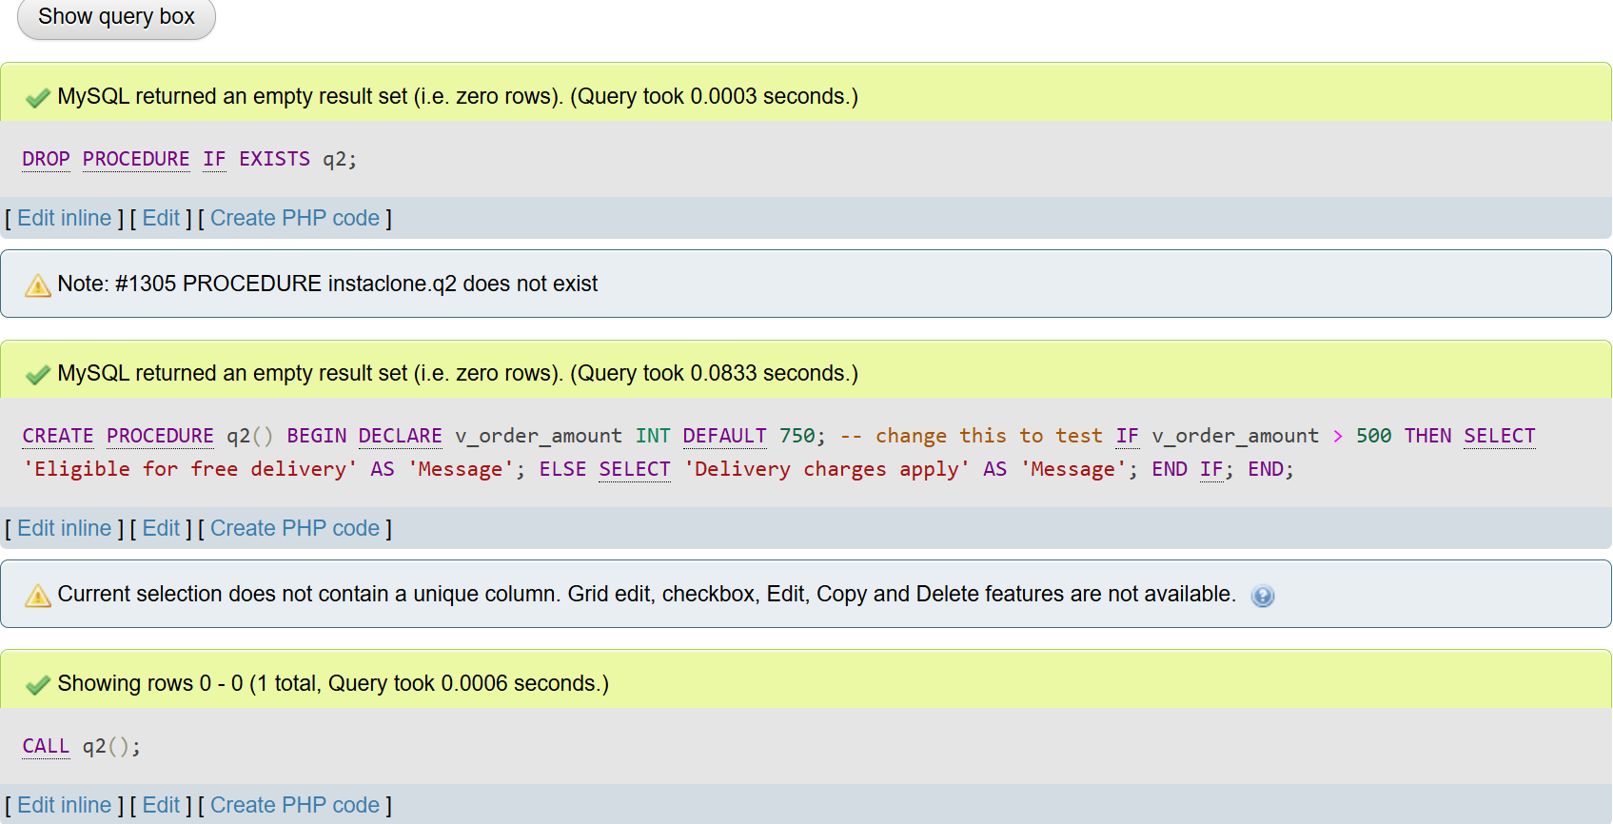

- CREATE PROCEDURE q3() BEGIN DECLARE v_counter INT DEFAULT 1; CREATE TEMPORARY TABLE IF NOT EXISTS tmp_nums (num INT); TRUNCATE tmp_nums; WHILE v_counter <= 5 DO INSERT INTO tmp_nums VALUES (v_counter); SET v_counter = v_counter + 1; END WHILE; SELECT num AS 'Number' FROM tmp_nums; END;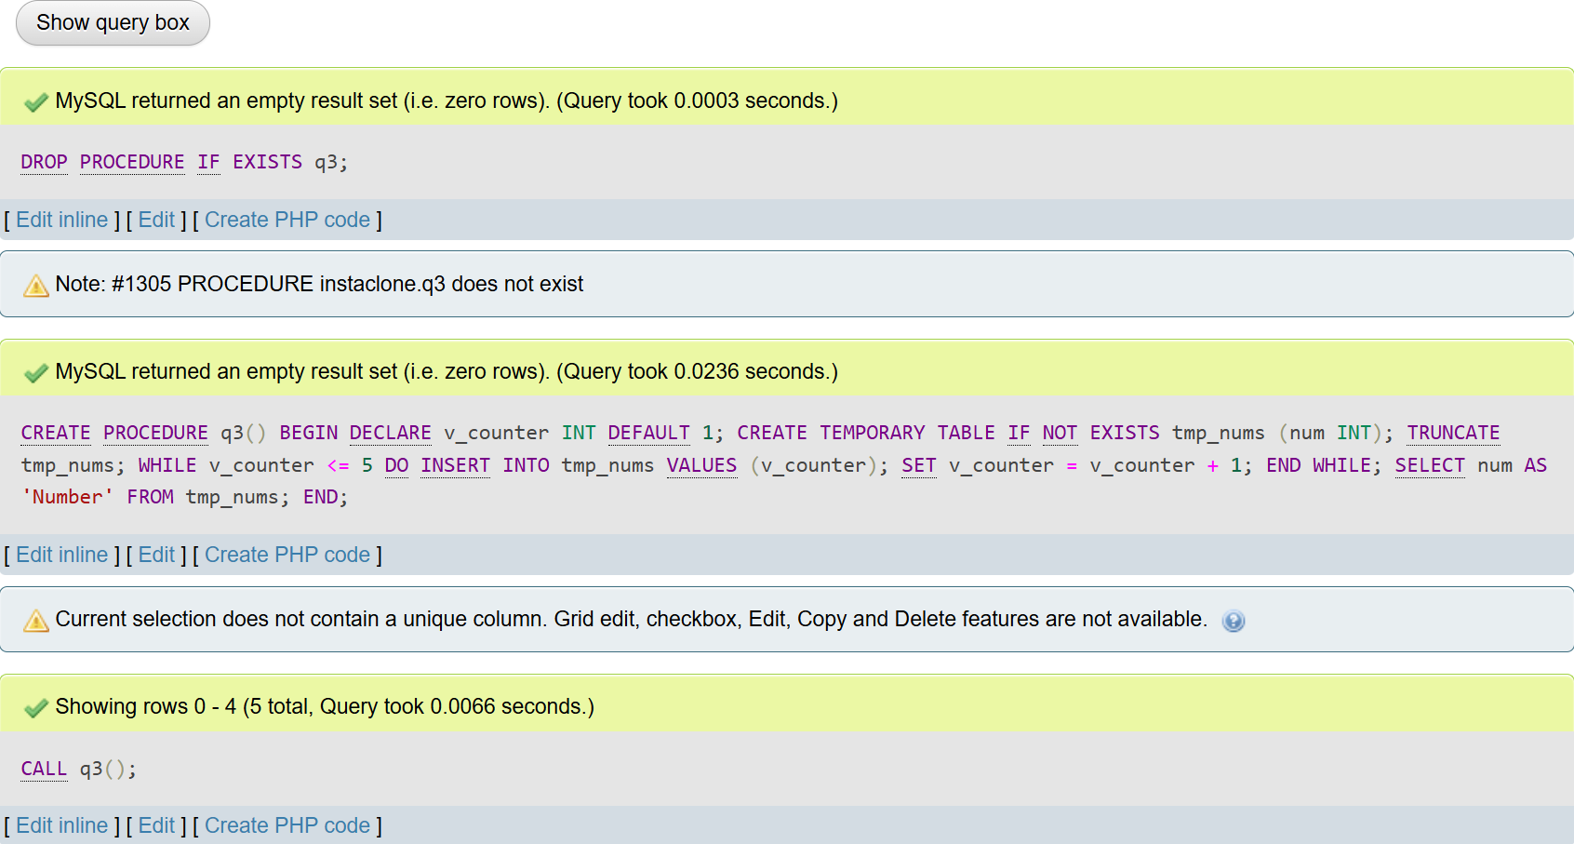

- CREATE PROCEDURE q4() BEGIN DECLARE v_done INT DEFAULT 0; DECLARE v_product_name VARCHAR(100); DECLARE c_products CURSOR FOR SELECT PRODUCT_NAME FROM PRODUCTS; DECLARE CONTINUE HANDLER FOR NOT FOUND SET v_done = 1; CREATE TEMPORARY TABLE IF NOT EXISTS tmp_products (name VARCHAR(100)); TRUNCATE tmp_products; OPEN c_products; fetch_loop: LOOP FETCH c_products INTO v_product_name; IF v_done = 1 THEN LEAVE fetch_loop; END IF; INSERT INTO tmp_products VALUES (v_product_name); END LOOP; CLOSE c_products; SELECT name AS 'Product Name' FROM tmp_products; END;
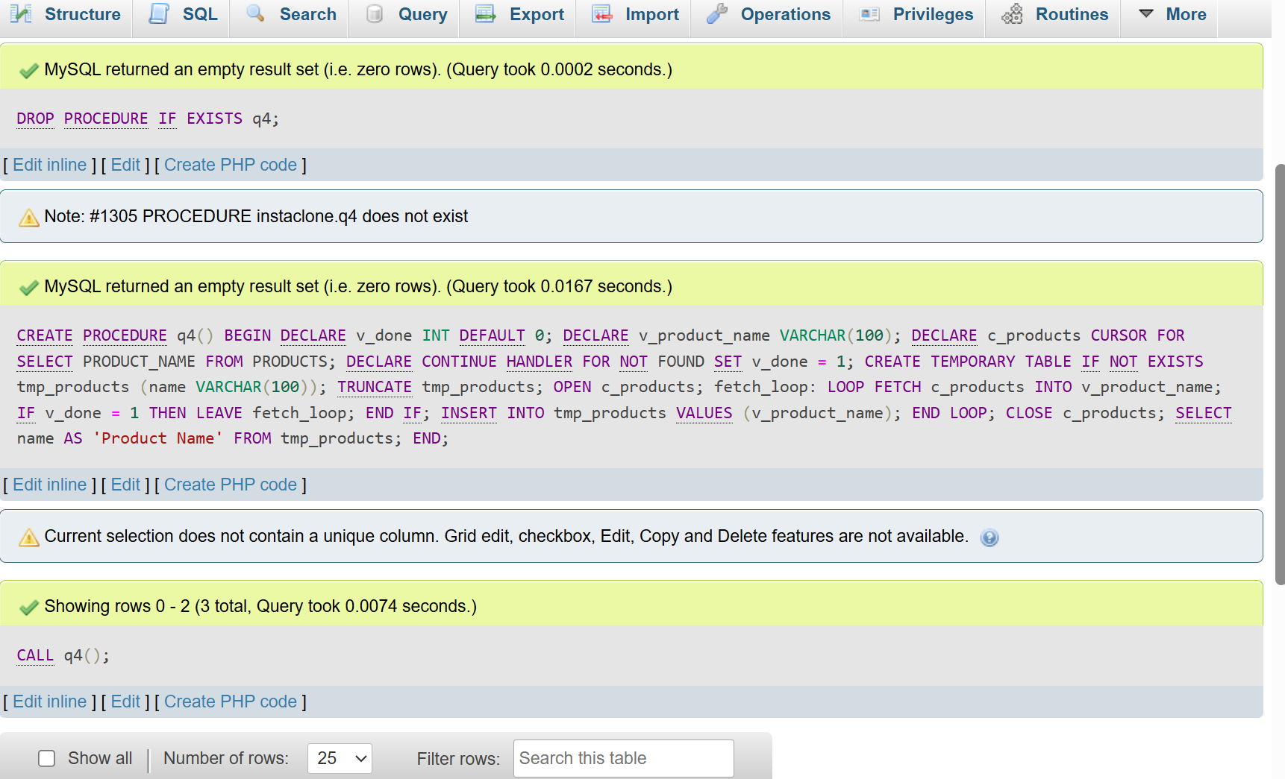

- CREATE PROCEDURE q5() BEGIN DECLARE v_num INT DEFAULT 100; DECLARE v_denom INT DEFAULT 0; DECLARE v_result DECIMAL(10,2); DECLARE EXIT HANDLER FOR 1365 BEGIN SELECT 'Cannot divide by zero' AS 'Message'; END; SET v_result = v_num / v_denom; SELECT v_result AS 'Result'; END;
